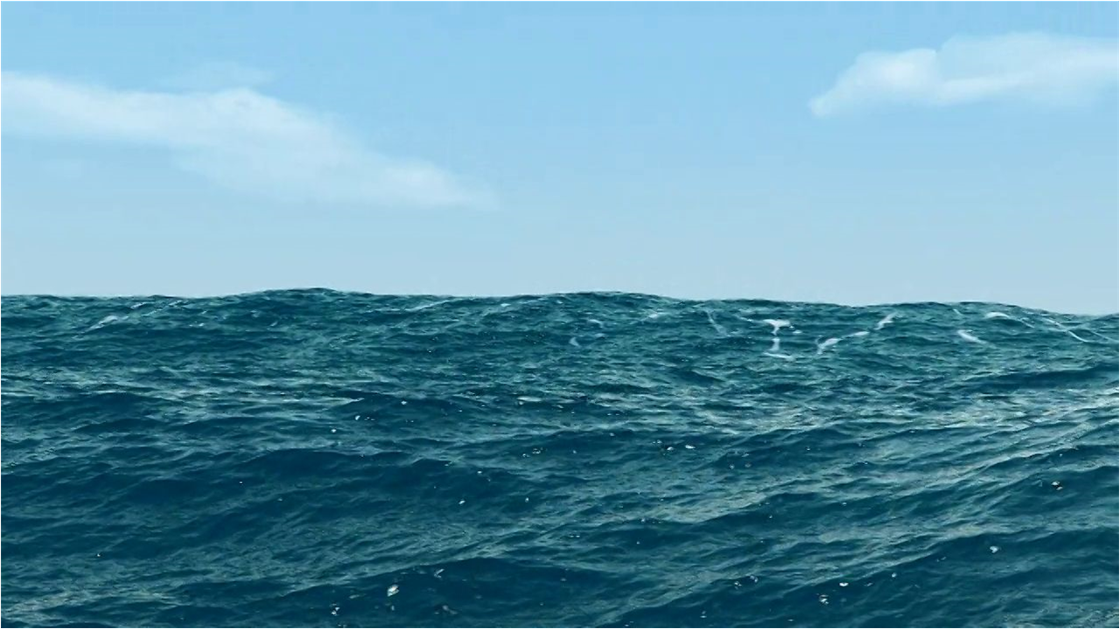DESIGN SPECIFICATION



**TABLE OF CONTENTS**

ABSTRACT2

DEVICE3

Measurements3

Components3

Materials3

SIMULATOR4

SimulatedReading 4

Resources 4

Simulator 5

DATABASE6

DASHBOARD6

Reading6

ReadingProxy7

Dashboard8

IMAGES10

**ABSTRACT**

**Background:** SmartBuoy is designed to be a fully self-contained water quality probe, able to be deployed into a body of water and monitored remotely via a GSM cellular network. SmartBuoy is an economical solution to water monitoring, meant for both amateur

and professional researchers.

The device is powered by 5-volt lithium ion battery, recharged by an onboard solar panel and includes sensors to measure electrical conductivity, pH, temperature, turbidity, and total dissolved solids. Location data is provided by an Adafruit GPS module. A data reading is taken every 30 seconds and streamed live. Every hour a reading is sent to a database for storage.

**Project Scope:** The project for this course is a GUI dashboard to retrieve and view the data readings. Because this is an online course, access to the device is unavailable to the class and professor. To mitigate this obstacle, I have created a second project to simulate the operations of the device. In addition to the dashboard and simulator, the database will also be created for data storage.

**Current State:** As of 2/28/2020

1. The simulator is fully functional. Clicking the power button begins a loop that creates artificial readings, posts them to Dweet.io and the SQL database. Every 30 seconds an artificial reading is created using random numbers. This data is sent to Dweet.io using HttpClient. Every hour a reading is sent to the SQL database.

Dweet.io is a service for sharing IoT data.

1. The database has been created using Microsoft Azure, with a single table added. Two stored procedures have been created. One to insert data and the other to retrieve it.
2. The dashboard is partially functional. Two datetime pickers specify the date range of reading to be retrieved from the database. Clicking the GET DATA button creates a SqlConnection and retrieves all rows within the specified range. This data is displayed in a DataGrid and plotted on a line chart. The location of each reading is plotted onto a map. When a row is selected, the data of each cell is displayed by custom gauge components. Clicking the GO LIVE gets the data from Dweet.io. At this time the connection is functional. The data is retrieved and sent to the corresponding gauges

**Operation:**

The database has been populated using the simulator. The dashboard can retrieve that data without the simulator running. To use the live data function the simulator must be running

**To Do List:**

1. Live data to the map, chart, and grid
2. Clean up code / Code reuse
3. Complete commenting and documentation
4. Complete error handling
5. Encrypt connection string in config file

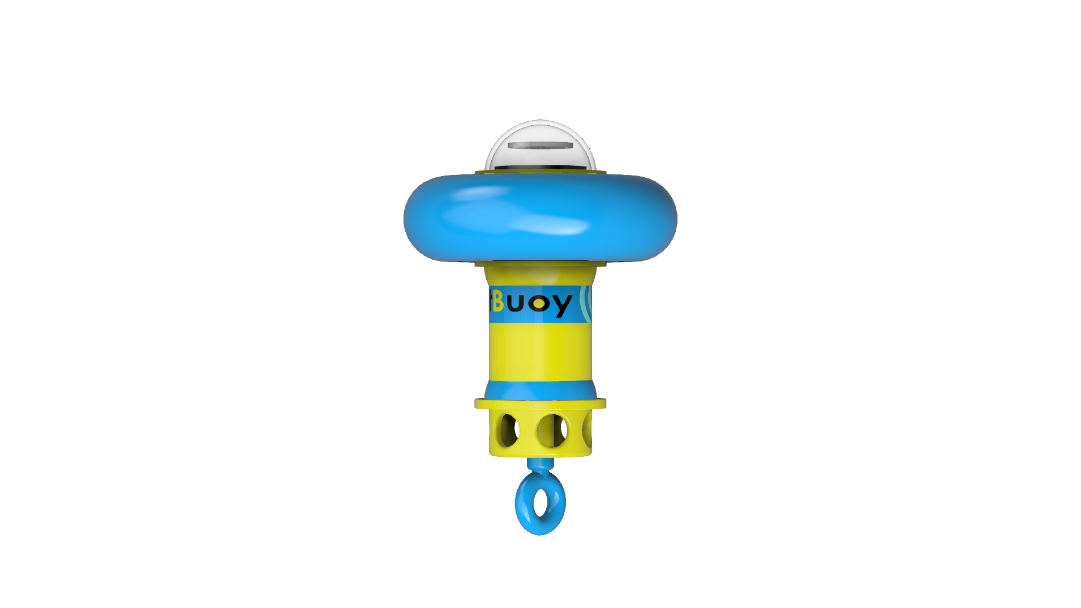 **DEVICE**

**Measurements:**

Overall Length: 450 mm

Body Diameter: 100 mm

Float Diameter: 300 mm

Weight: 1.2 kg

**Materials:**

Body: PLA Thermoplastic

Dome: Acrylic

Float: Vinyl

**Components:**

Acrylic Dome

PLA Body

Vinyl Floatation Ring

Solar Panel

5-volt Lithium Battery

Mayfly Microcontroller

SD Datalogger

SIM 900 Cellular Modem

Adafruit GPS Module

Thermometer

Turbidity Probe

pH Probe

Electrical Conductivity Probe

**SIMULATOR : SimulatedReading class**

**SimulatedReading :** Class used to simulate and post readings

**readingDT :** string variable for the current date and time

**battery :** double variable for voltage

**pH :** double variable for pH

**conductivity :** double variable for electrical conductivity

**temperature :** double variable for temperature

**dissolvedSolids :** double variable for total dissolved solids

**turbidity :** double variable for turbidity

**longitude :** double variable for longitude

**latitude :** double variable for latitude

**GetReading() :** void method Generates random numbers and assigns them to battery, pH, conductivity, temperature, dissolvedSolids, turbidity, longitude, and latitude. Assigns the current DateTime to readingDT

**BroadcastLive() :**  Async Task method creates a string from the values of readingDT, battery, pH, conductivity, temperature, dissolvedSolids, turbidity, longitude, and latitude. Then uses HttpClient to post the values to Dweet.io

**SendToDatabase() :** void method creates a SqlConnection and sends the values of readingDT, battery, pH, conductivity, temperature, dissolvedSolids, turbidity, longitude, and latitude to the database in a SqlCommand containing the PostReadings stored procedure

**SIMULATOR : Resources**

**Resources :** Directory

**LED_RedOn :** Image of red LED on

**LED_RedOff :** Image of red LED off

**LED_GreenOn :** Image of green LED on

**LED_GreenOff :** Image of green LED off

**SIMULATOR : Simulator class**

**Simulator :** Implements the SimulatedReading class and creates the GUI

**reading :** SimulatedReading

**PowerIsOn :** bool flag to indicate the state of the simulator

**btnPowerOn :** Button to start the ReadingTimer – changes the image of indicatorPower from LED_RedOff to LED_RedOn

**btnPowerOff :** Button to stop the ReadingTimer – changes the image of indicatorPower from LED_RedOn to LED_RedOff

**indicatorPower :** PictureBox contains an image of an LED to show the state of the simulator

**indicatorSQL :** PictureBox contains an image of an LED to show activity of the SQL connection

**indicatorLIVE :** PictureBox contains an image of an LED to show activity of the HTTP connection

**indicatorBATT :** PictureBox contains an image of an LED to show activity of a battery reading

**indicatorTEMP :** PictureBox contains an image of an LED to show activity of a temperature reading

**indicatorTDS :** PictureBox contains an image of an LED to show activity of a TDS reading

**indicatorEC :** PictureBox contains an image of an LED to show activity of an EC reading

**indicatorPH :** PictureBox contains an image of an LED to show activity of a pH reading

**indicatorGPS :** PictureBox contains an image of an LED to show activity of a longitude and latitude reading

**ReadingTimer :** Timer calls the FlashLEDs() method and the GetReading(), BroadcastLive(), ToDatabase() methods of the SimulatedReading class

**FlashLEDs() :** void method to consecutively change the image of indicatorSQL, indicatorLIVE, indicatorBATT, indicatorTEMP, indicatorTDS, indicatorEC, indicatorPH, and indicatorGPS PictureBoxes from LED_GreenOff to LED_GreenOn. Sleep for 200ms, then change back to LED_GreenOff.

**DATABASE**

**Reading :** Table

**readingDT :** field (datetime, null)

**battery** **:** field (decimal(2,1), null)

**temperature** **:** field (decimal(4,1), null)

**pH** **:** field (decimal(2,1), null)

**conductivity** **:** field (decimal(4,0), null)

**dissolvedSolids** **:** field (decimal(3,0), null)

**turbidity** **:** field (decimal(2,1), null)

**longitude** **:** field (decimal(7,5), null)

**latitude** **:** field (decimal(7,5), null)

**GetHistoricReadings :** Stored Procedure to select rows from Reading where the value of readingDT is greater than @START and less than @END

**PostReadings :** Stored Procedure to insert the values @readingDT, @battery, @temperature, @pH, @conductivity, @dissolvedSolids, @turbidity, @latitude, @longitude into the fields readingDT, battery, temperature, pH, conductivity, dissolvedSolids, turbidity, latitude, longitude in the Reading table

**DASHBOARD : Reading class**

**Reading :** Class used to retrieve and manipulate reading data

**DATETIME :** string variable for the current date and time

**VOLTS :** double variable for voltage

**TEMP :** double variable for temperature

**PH :** double variable for pH

**EC :** double variable for electrical conductivity

**TDS :** double variable for total dissolved solids

**TURB :** double variable for turbidity

**LAT :** double variable for latitude

**LON :** double variable for longitude

**DASHBOARD : ReadingProxy class**

**ReadingProxy :** Class for using data from deserialized JSON string

**Rootobject :** Root class of JSON string

**_this :** string – not used

**by :** string – not used

**the :** string – not used

**with :** With[] – not used

**With :** Subclass of the JSON string

**thing :** string – not used

**created :** DateTime – not used

**content :** Content – not used

**Content :** Subclass of the JSON string – contains data

**DATETIME :** string variable for the current date and time

**VOLTS :** double variable for voltage

**TEMP :** double variable for temperature

**PH :** double variable for pH

**EC :** double variable for electrical conductivity

**TDS :** double variable for total dissolved solids

**TURB :** double variable for turbidity

**LAT :** double variable for latitude

**LON :** double variable for longitude

**WebResponse() :** method retrieves the most recent Dweet.io post. Returns the data as a Reading object

**DASHBOARD : Dashboard class**

**Dashboard :**  Implements the Reading class, ReadingProxy class, and creates the GUI

**dtStart :** DateTimePickers used to set the start date for the data to be retrieved from the database.

**dtEnd :** DateTimePickers used to set the end date for the data to be retrieved from the database.

**btnHistoric :** Button that initiates the retrieval sequence. A connection is made to the database and a command is sent to retrieve the rows with dates in the specified range.

**dataHistoric :** A DataGridView that displays the retrieved data. Each row of the grid is a row from the database; which represents one transmission from the SmartBuoy.

**lineChart :** Links to dataHistory as its data source to graph all of the measurements.

**rangeSlider :** A slider whose number of ticks is set to equal the number of rows retrieved from the database. The value of the slider’s position corresponds to a row from dataHistoric. That value is used to select a row number, then each cell of that row is mapped to it’s the appropriate gauge for display.

**BuoyMap :** Uses the latitude and longitude columns of dataHistoric to plot points representing the location of the device when each reading was taken. Points are displayed beginning with the first row of dataHistoric up to the row selected by rangeSlider.

**btnLive :** A button opens a connection to Dweet.io. Dweet acts as an intermediate between the SmartBuoy and the GUI. Dweet receives the data from the SmartBuoy and stores the five most recent transmissions. The dashboard uses an HTTP request to get the most recent reading.

**gaugeBatt :** A custom control to view the battery voltage. The Value sets the level of the gauge. The Text displays the value as text.

**gaugeTemp :** A custom control to view the temperature. The Value sets the level of the gauge. The Text displays the value as text.

**gaugeEC :** A custom control to view the electrical conductivity. The Value sets the level of the gauge. The Text displays the value as text.

**gaugeTDS :** A custom control to view the total dissolved solids. The Value sets the level of the gauge. The Text displays the value as text.

**gaugeTurb :** A custom control to view the turbidity. The Value sets the level of the gauge. The Text displays the value as text.

**DASHBOARD : Dashboard class**

**gaugePH :** A custom control to view the pH. The Value sets the level of the gauge. The Text displays the value as text.

**LiveTimer :** Timer calls methods to retrieve the live data. The interval is set to 30 seconds

**btnZoomIn :** A button to zoom in on the map

**btnZoomOut :** A button to zoom out on the map

**MapHost** A control to host the WPF map control

**IMAGES**

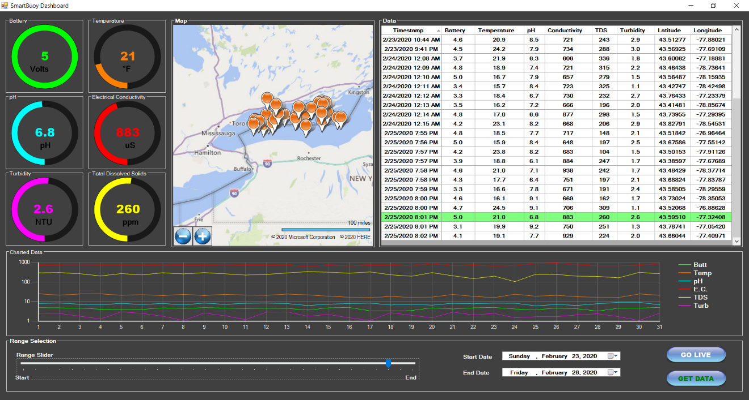

**Image 1.1 : Dashboard**

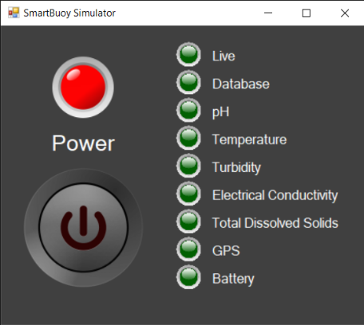

**Image 1.2 : Simulator**